- The original “test_and_set” operation leads to busy waiting, meaning a process might indefinitely attempt to enter the critical section while other processes are blocked, failing to ensure bounded waiting.

- This code ensures mutual exclusion by only updating *value if it matches the expected value, thus preventing race conditions. Bounded waiting is achieved because each process will eventually get its turn to enter the critical section.
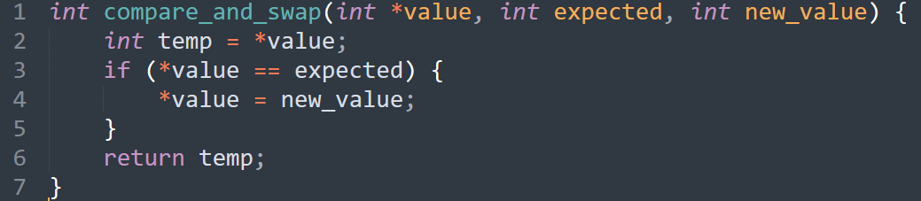

  - No, because each process chooses a number that is one greater than the current maximum number.
  - No, removing this loop can cause processes to conflict while choosing numbers, breaking mutual exclusion.
  - Mutual Exclusion: Each process checks other processes’ numbers before entering the critical section, ensuring no two processes are in the critical section simultaneously.
Progress: Every process will eventually enter the critical section because the numbers are incremented.
Bounded Waiting: Each process will enter the critical section within a bounded number of attempts, as the numbers are finite and incremented.
- Blocking avoids wasting CPU resources because a process waiting for a semaphore does not consume CPU time, unlike busy waiting, which continuously checks the condition, wasting CPU cycles.
- Semaphore:
Advantages: Simple and flexible.
Disadvantages: Prone to errors, especially in complex synchronization problems.
Monitor:
Advantages: Well-structured and easier to understand and use.
Disadvantages: Less flexible and may have performance issues in some cases compared to semaphores.
- 